HUMANITARIAN

**RESPONSE PLAN**

JANUARY-DECEMBER 2019

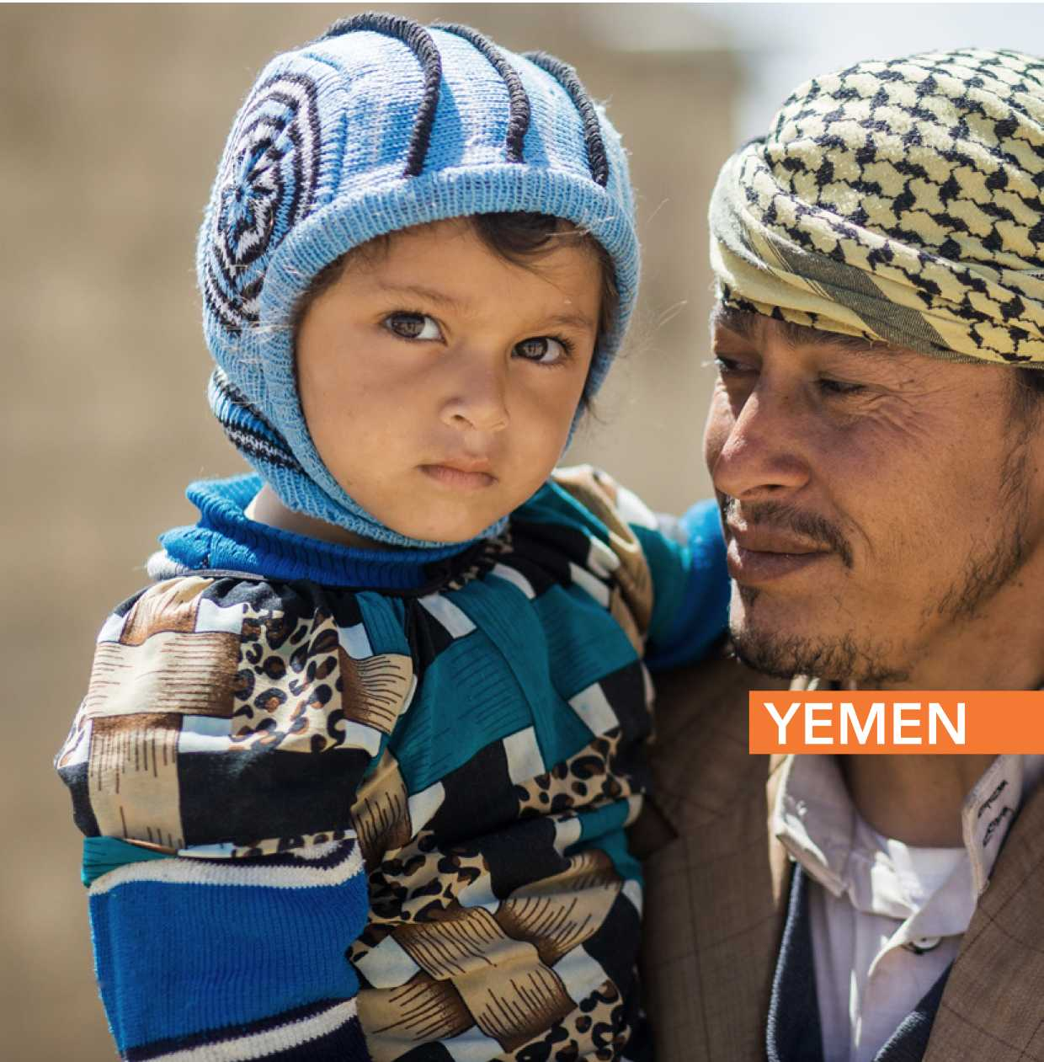

*F* FEBRUARY 2019

Photo: UNICEF

YEMEN REFERENCE MAP

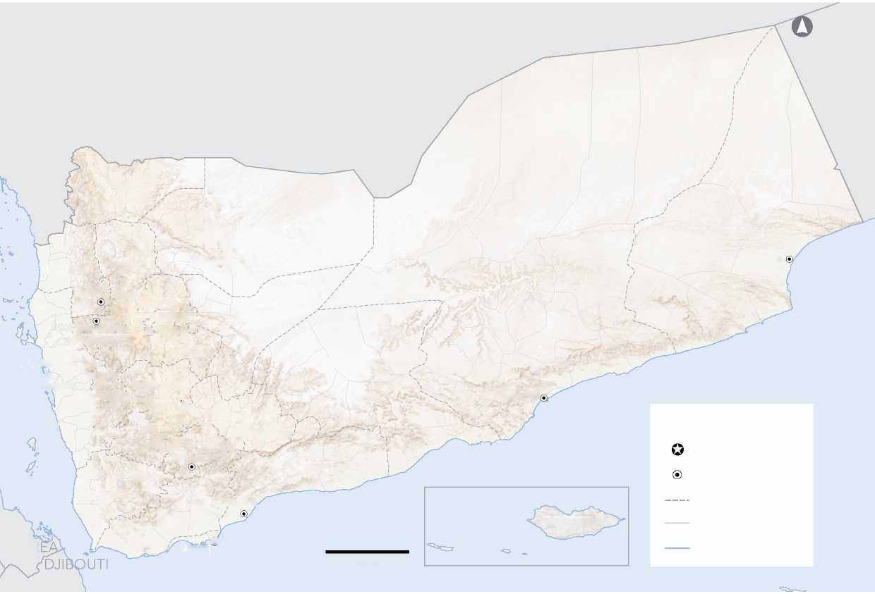

SAUDI ARABIA

OMAN

**HADRAMAUT**

**AL JAWF**

**AL MAHARAH**

**AlGhaydah**

**® Al Hazm**

**AMRAN**

**HAJJAH**

*Arabian Sea*

**SANA'A**

**SHABWAH**

**Al Hudaydah**

**Al Mukalla City**

**® Ataq**

LEGEND

*Red Sea*

Capital City

**ABYAN**

Governorate Capital

**®Taizz**

**TAIZZ**

Governorate Boundary

*Gulf of Aden*

**SOCOTRA**

District Boundary

ERITR

Coastline

100 Km

**Hajjah City**

**SA'ADA**

**® Sa'adah**

**MARIB**

**® Marib City**

**Amran / '**

**® AMANAT**

**•’"f AL ASIMAH**

**LAHJ Zingibai**

**Al Hawtah ®**

**® Aden**

**ADEN**

**AL HUDAYDAH**

**® Al Jabin**

**Al Mahwait City** q **Sana'a**

**ALMAHWIT**

**® DHAMAR**

**RAYMAH ®**

***' Dh'" D* Dhamar City**

**'f *ALBAY* _ AL BAYDA**

**'-x,Z IBB Al Bayda City**

**®Ibb ALDHALEJEf' ® Ad Dhale'e-' '**

The boundaries and names shown and the designations used on this map do not imply official endorsement or acceptance by the United Nations. Creation date: 28 November 2018. Sources: GoY/MoLA/CSO.

This document is produced by the United Nations Office for the Coordination of Humanitarian Affairs (UNOCHA) on behalf of the Humanitarian Country Team and partners.

This document provides the Humanitarian Country Team’s shared understanding of the crisis, including the most pressing humanitarian needs, and reflects its joint humanitarian response planning.



[www.unocha.org/yemen](http://www.unocha.org/yemen)

[www.ochayemen.org/hpc](http://www.ochayemen.org/hpc)



[www.humanitarianresponse.info/en/operations/yemen](http://www.humanitarianresponse.info/en/operations/yemen)

*@OC* @OCHAYemen

**TABLE OF CONTENT**

*///////////////^^^^*

**PART I: COUNTRY STRATEGY**

The humanitarian response plan at a glance 04

Overview of the crisis 05

2019 Humanitarian strategy 10

Humanitarian access 13

Targeting and monitoring 15

Summary of needs, targets and requirements 16

1. CLUSTER PLANS

Food Security and Agriculture 18

Nutrition 19

Health 20

Water, Sanitation and Hygiene 21

Protection 22

Shelter and Site Management 23

Education 24

Refugee and Migrant Multi-Sector 25

Rapid Response Mechanism 26

Logistics 27

Emergency Telecommunications 28

Coordination 29

*///////////////^^^^*

1. ANNEX

Strategic Objectives, indicators and targets 31

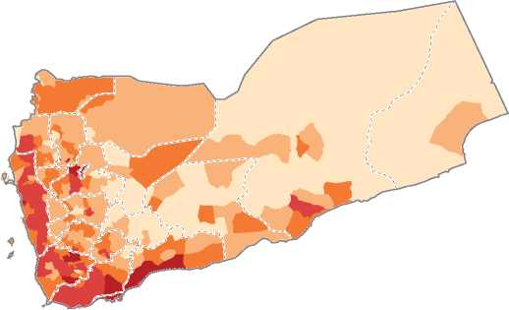**THE HUMANITARIAN RESPONSE PLAN**

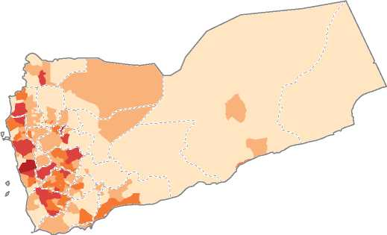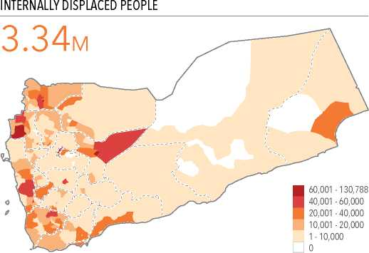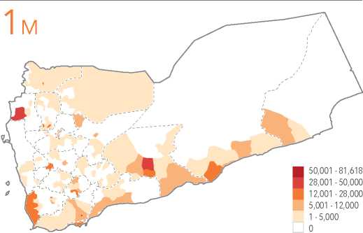AT A GLANCe

**ESTIMATED POPULATION**

**PEOPLE IN NEED**

**REQUIREMENTS (US$)**

**HUMANITARIAN PARTNERS**

**30.5m**

**24.1m**

**$4.2bn**

**254**

**STRATEGIC OBJECTIVE 1**

Helping millions of destitute Yemenis overcome hunger

**STRATEGIC OBJECTIVE 2**

Reducing outbreaks of cholera and infectious diseases

**STRATEGIC OBJECTIVE 3**

©

Promoting the dignity of displaced families living in emergency and IDP settlements

**STRATEGIC OBJECTIVE 4**

Reducing the risk of displacement and violence against civilians and facilitating the recovery of people traumatized by the conflict

**STRATEGIC OBJECTIVE 5**

©

Preserving the capacity of public sector institutions to deliver life-saving basic services

**04**

**OPERATIONAL PRESENCE: NUMBER OF PARTNERS**

**PEOPLE WHO NEED HUMANITARIAN ASSISTANCE**

24.1M

254 organisations

**1** 290,001 - 513,000 178,001 - 290,000 108,001 - 178,000

■ 55,001 - 108,000  
1,500 - 55,000

**1**31 - 45

23 - 30

17 - 22

■ 10 - 16

**RETURNEES**

**OVERVIEW OF**

The CRISIS

The humanitarian crisis in Yemen is the worst in the world, driven by conflict, economic collapse and the continuous breakdown of public institutions and services.

230 DISTRICTS AT RISK OF FAMINE

104 DISTRICTS WITH THE MOST SEVERE NEEDS ACROSS

**05**

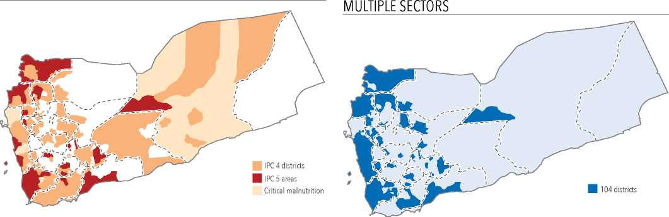

1. **After four years of continuous conflict, the humanitarian crisis in Yemen is the worst in the world.** A higher percentage of people face death, hunger and disease than in any other country. The degree of suffering is nearly unprecedented. Eighty percent of the entire population requires some form of humanitarian assistance and protection, an increase of 84 per cent since the conflict started in 2015. Twenty million Yemenis need help securing food and a staggering 14 million people are in acute humanitarian need.
2. **Ten million people are one step away from famine and starvation.** Two hundred and thirty of Yemen’s 333 districts are now food insecure. This includes 148 districts which are classified as phase 4 under the Integrated Phase Classification (IPC) system, 45 districts with families in IPC phase 5, and 37 districts which have global acute malnutrition rates above 15 percent. For the first time in Yemen, assessments confirm the presence of catastrophic levels of hunger. At least 65,000 people are already in advanced stages of extreme food deprivation and 238,000 people in districts with IPC 5 areas will face similar conditions if food assistance is disrupted for even a few days.
3. **Seven million, four hundred thousand people, nearly a quarter of the entire population, are malnourished, many acutely so.** Acute malnutrition rates exceed the WHO emergency threshold of 15 percent in five governorates and close to 30 percent of all districts record critical levels of malnutrition. Two million malnourished children under five and 1.1 million pregnant and lactating women require urgent treatment to survive.
4. **Conditions are worsening at a nearly unprecedented rate.** In 2014, prior to the conflict, 14.7 million people required assistance. In 2015, this number increased to 15.9 million; in 2016 to 21.2 million and in 2018 to 22.2 million. In 2019, 24.4 million people need assistance to survive. The number of severely food-insecure districts has risen by 60 percent in one year from 107 districts in 2018, to 190 in 2019. In the last 12 months, the number of people unable to predict when they will next eat has risen by 13 percent and is expected to increase by 20 percent or more unless humanitarian operations are dramatically expanded in the early months of 2019.
5. **The severity of suffering is shocking.** The number of civilians in acute humanitarian need across all sectors has risen 27 percent since last year. In the health sector, the number has risen 49 percent to 14 million. In the shelter sector, the number has increased 73 percent; in protection 26 percent and in education 32 percent. In every cluster, at least half of all the people in need are in acute need. Acute needs are highest in the conflict-impacted governorates of Hodeida, Sa’ada and Taizz, where more than 60 per cent of the population requires help to survive.
6. **Every humanitarian sector and most, if not all parts of the country, are impacted by the conflict.** In the health sector, 203 districts are classified as acute. Less than 50 per cent of health facilities across the country are fully functional and those which are operational lack specialists, equipment and medicines. Immunization coverage has decreased by 20-30 percent since the conflict started and most health personnel

have not received salaries for two years, or more. In the shelter sector, 207 districts are now classified as acute. In the water and sanitation sector, 167 districts are classified as acute, a four-fold increase since 2018. Only 22 percent of rural and 46 percent of urban populations are connected to partially functioning public water networks and less than 55 percent of the population has access to safe drinking water. In the education sector, 36 per cent of school-age girls and 24 per cent of boys do not attend school. Fifty one percent of teachers have not been paid since 2016, hundreds of schools have been destroyed and more than 1,500 have been damaged by air strikes or shelling.

NUMBER OF CONFLICT INCIDENTS (OCT 2017 - SEP 2018)

**06**

**Asimah**

**Amran**

**Marib**

**Sana'a**

**Shabwah**

**Dhamar**

**Abyai**

**AlBayda**

**15,170**

Number of Conflict Incidents

801 - 1,323

401 - 800

151 - 400

51 - 150

1 - 50

**Hadramaut**

**Al Maharah**

**Al Jawf**

* Incidents include airstrikes, armed clashes and shelling; increase from the previous year is due to more accurate reporting, rather than an increase in conflict. Source: UN source, October 2017 - September 2018

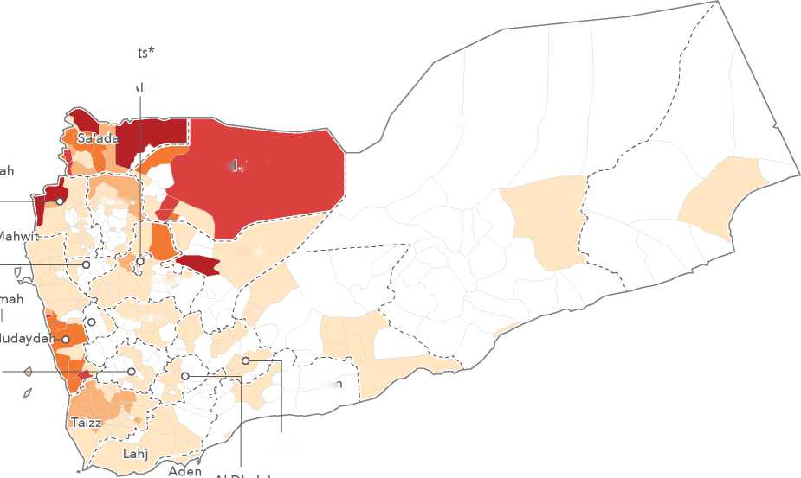

1. **The human cost of the conflict is enormous.** Partners estimate that 70,000 people in Yemen have been killed since early 2016. The UN has verified nearly 18,000 conflict- related civilian casualties and in the last year alone, civilian casualties have risen by at least 11 percent. Indiscriminate attacks on civilians and civilian infrastructure and breaches of international humanitarian law are widespread. Fighting has damaged water and electricity infrastructure, irrigation systems, agricultural sites, hospitals, water points, sanitation plants and economic assets. Areas along many of the more than 30 front-lines have been mined. The number of grave violations of children’s rights has more than doubled in the past year and reported incidents of gender-based violence have increased 70 percent.
2. **Since 2015, nearly 15 percent of the entire population, 4.3 million people, have been forced to flee their homes;** 3.3 million people are still displaced. More than 685,000 people have been newly displaced in the past year, the majority by fighting in Hodeida and along the western coast. Close to 74 percent of displaced families outside hosting sites are living in rented accommodation; 22 percent are being hosted by families. Nearly 300,000 of the most destitute and vulnerable IDPs are living in 1,228 collective sites; 83 per cent of these sites have no health services, 39 percent report water deficits and 43 percent have no toilets. Nearly one-third of all IDPs live in the 104 districts across the country with the highest convergence of complex, multi-dimensional problems including food insecurity, insufficient protection safeguards, governance deficits, disease outbreaks and the widespread lack of basic public services including health care, water, sanitation and electricity.
3. **People are now at higher risk, and less able to cope, than at any stage of the conflict.** Negative coping mechanisms and harmful practises are spreading across the country. Child marriage is estimated to have increased threefold between 2017 and 2018. Child recruitment into armed forces continues and extreme forms of child labour are expanding. Partners report disturbing increases in family and sexual and gender-based violence. Hundreds of thousands of households have fallen into destitution and tens of millions face immiseration and extreme deprivation. Conditions are particularly difficult for older people, people with disabilities and other marginalized and socially excluded groups.
4. 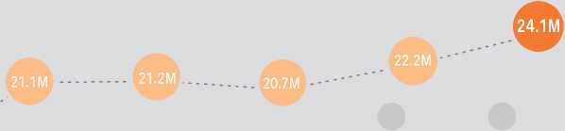**Refugees and migrants continue to enter Yemen.** More than 422,000 refugees and migrants, most from the Horn of Africa, are living in precarious conditions because of their status. Thirty percent of the 150,000 new arrivals in 2018 were unaccompanied minors; four percent were children under five. The majority face discrimination, nearly a third have no income, some are arbitrarily detained and others trafficked.

PEOPLE IN NEED (2013 - 2019)

**14.7M**

**13.1M**

2013 2014 2015 Revised 2015 2016 2017

2018 **2019**

Sources: CAP 2013; PMR 2017; HNOs 2014-2019

1. **The rapid depreciation of the Yemeni riyal during the last quarter of 2018, combined with credit and import restrictions, has put millions of people at further risk.** Within the space of a few short weeks in September and October 2018, as the riyal lost 65 percent of its value, Yemen was brought to the brink of famine. Tens of thousands of destitute families across the country were unable to purchase the commodities they needed to survive, including food and fuel. The crisis became so severe so quickly, the UN Security Council was seized with the issue, insisting that urgent steps be taken to support the currency and ease credit and import restrictions.
2. **The events of September and October followed three years of continuing economic collapse.** Since 2015, Yemen’s economy has contracted by nearly 50 percent. Cumulative losses in real GDP are estimated at USD 49.9 billion and at least 600,000 jobs have been lost. Agricultural production and fishing, employing nearly 70 percent of the workforce, have shrunk by a third. More than 80 per cent of Yemenis now live below the poverty line, an increase of one-third since the conflict began. Public sector salaries are either unpaid or irregularly paid, disrupting incomes for more than a quarter of the population. In northern Yemen, at least 500,000 civil servants have received no salaries for nearly three years.

ESTIMATED GDP LOSSES (2015-2018)

Potential GDP without conflict — GDP with conflict

**$49.9Bn**

ra Cumulative losses in real GDP during 2015-2018

|  |  |  |  |
| --- | --- | --- | --- |
| **25.5** | **26.6** | **27.6** | **28.7** |
|  | o | O |
| o | **o** |  |  |
| **17.3** | **14.7** | **13.1** | **13.5** |
| 2015 | 2016 | 2017 | 2018 |

Source: MOPIC, Socioeconomic Update (issue 34), June 2018

1. **The loss of purchasing power has occurred at the same time that the prices of basic commodities are soaring.** Monthly imports through the key ports of Hodeida and Saleef are currently 20 percent lower than 2015, forcing prices upwards in a country that imports nearly 90 percent of staple commodities. Inflation has risen 40 percent in one year, driven by the liquidity crisis, exhaustion of foreign reserves and the rapid expansion of money supply. Price pressures have been greatest on core commodities. The cost of a food basket increased 60 percent last year and average food prices are now nearly 150 per cent higher than before the conflict. Fuel prices rose by 200 percent in 2018 compared to pre-crisis prices, impacting agriculture, water supply, transport, electricity, health and sanitation services. Oil and gas production, which provided 60 percent of fiscal revenue and foreign exchange before the crisis, have plummeted. Remittances from abroad also have dropped sharply due to restrictions on transfers to Yemeni banks.

All indicators point to a difficult year ahead

1. **The largest humanitarian operation in the world is underway in Yemen.** During 2018, 48 international and 194 local partners have worked together to reach an average of eight million people each month with life-saving support. At least one form of humanitarian assistance has been provided during the past twelve months to families in all of Yemen’s 333 districts. The reach of the operation is impressive. In 2018, the health cluster assisted 12 million people each month, the WASH cluster 11.5 million people and the food security and agriculture cluster reached 7.5 million people.
2. **The impact of the operation has been demonstrable and significant.** Millions of lives have been saved and hundreds of thousands of Yemeni families have been helped to survive one of the most difficult periods in their country’s history. Of the many milestones achieved during 2018, four stand out in terms of impact, scale and efficiency. First, as a direct result of the massive, synchronized and very rapid scale-up of all forms of humanitarian aid achieved during 2018, 45 of the 107 districts facing extreme food insecurity at the beginning of last year are no longer pre-famine. Second, food security partners have successfully managed one of the largest, fastest and most difficult scale-ups of assistance anywhere in the world increasing the number of people

**07**

NUMBER OF PEOPLE IN NEED BY SECTOR

**08**

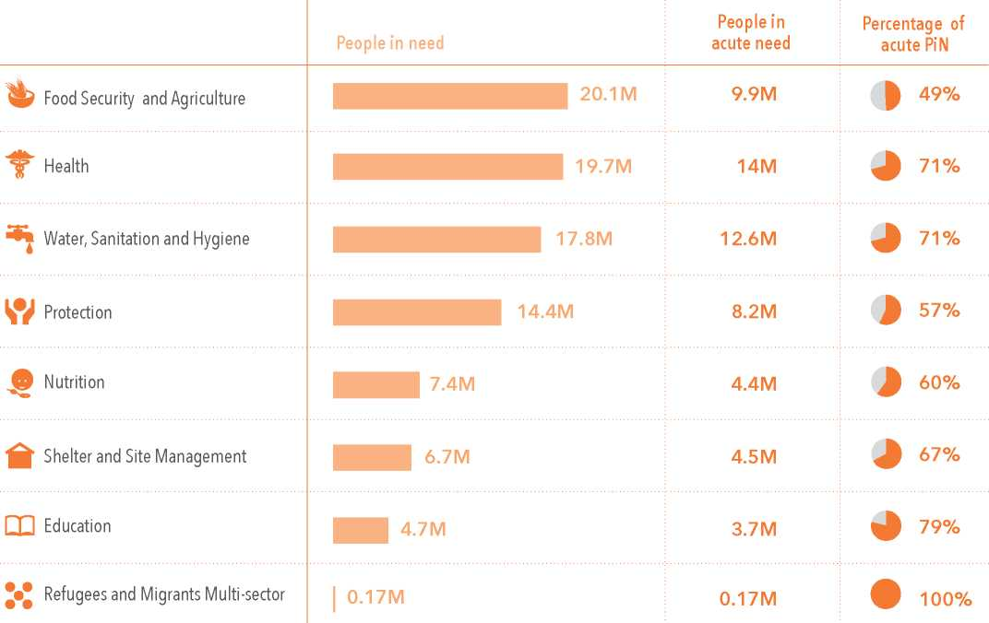

reached each month with food assistance from three million to an astonishing 10 million by the first month of 2019. Third, nutrition partners, working through public institutions, have helped to cure a higher percentage of children suffering from severe acute malnutrition than in any comparable operation globally. Fourth, health partners, working in close partnership with local institutions, have stemmed the largest cholera outbreak in modern history, reducing the number of new cases from one million in the year and a half before to 311,000.

1. **Major impact has been achieved across virtually every cluster.** For the first time in the conflict, 680,000 people fleeing their homes have received emergency assistance within days, and sometimes, hours of their displacement. Hundreds of humanitarian staff, both international and national, stayed in Hodeida during six months of near constant conflict and bombardment, helping to keep the port open, and storing, loading and dispatching nearly half of million metric tonnes of wheat to districts across the country. Vaccination campaigns against diphtheria, measles, rubella and polio have reached 13.2 million people. More than 230,000 women and girls have benefitted from life-saving reproductive health services and partners have helped to ensure the safe delivery of 20,700 new-bornes. Half a million Yemenis in 19 governorates have received protection services including psychosocial support, assistance with documentation, legal services and comprehensive case management for children and sur­vivors of sexual and gender-based violence.
2. **Confronted with an increasingly difficult operating environment, the humanitarian operation is better run, better monitored and more efficient.** For the first time, partners have developed a comprehensive contingency plan and pre-positioned emergency supplies in hubs near areas where mass displacement is expected. An Emergency Concept of Operations detailing assessment, targeting and monitoring protocols has been elaborated for Hodeida, helping to ensure a more principled response even at the height of the fighting. A Rapid Response Mechanism for reaching newly displaced families within hours has been introduced for the Hodeida operation and is now being expanded nationwide to 307 districts.
3. **Faced with increasing needs and limited capacity, the HRP was prioritized at mid-year across first-line, second line and full cluster responses.** After being restructured, the Multi-Cluster Location Assessment was used in September and October to measure needs and confirm baselines in 6,791 locations across the country. SMART surveys have been conducted for the first time since 2016 in 15 governorates and

**BENEFICIARIES BY CLUSTER (JAN-DEC 2018)**

**Food Security and Agriculture**

Nutrition

Health

**7.5m**

People Reached

**5.7m**

People Reached

**12.0m**

People Reached

Water, Hygiene and Sanitation

Protection

Shelter and Site Management

**11.5m**

People Reached

**4.8m**

People Reached

**1.4m**

People Reached





**Education**

Refugee and Migrant Multi-Sector

*Etege* Emergency Employment and *Commu* Community Rehabilitation

**1.8m**

People Reached

**0.16m**

People Reached

**0.33m**

People Reached

**09**



the IPC assessment was successfully conducted on the basis of the most rigorous protocols in IPC history in all of Yemen’s 333 districts. Third party monitoring has been expanded across eight sectors and for the first time, is being done across the HRP has a whole. After months of discussion, a biometric system for verifying foo security beneficiaries will be introduced during the first quarter of 2019.

1. **Partners are already gearing up in the expectation that conflict will continue, and may intensify, along at least some of the more than 30 front-lines.** In the most likely scenario, partners are bracing for the possibility that between 500,000 and 1.2 million people may be newly displaced. In areas where the parties redeploy under the auspices of the peace process, partners are also preparing to support as many as 750,000 people who may return to their homes. Economic problems are likely to continue including fluctuations in the exchange rate, import restrictions and delays in paying civil servants. Shortages of fuel are expected and the prices of basic commodities, including food, are likely to remain out of reach for millions of families. Partners also recognize that the operational budgets for ministries and public institutions will almost certainly remain inadequate to address the demand and need for health care, education, water, sanitation and social protection.

**2019 HUMANITARIAN**

STRATeGY

humanitarian partners are committed to doing everything possible during 2019 to help civilians in Yemen survive violence, secure food and receive the nutrition, health, wASh, shelter, education and protection support they are entitled to under international humanitarian and human rights law. Recognizing the magnitude of the crisis, but working with only limited capacity and confronted by multiple obstacles, humanitarian partners are adopting a high-impact strategy with five priority strategic objectives. During 2019, in accordance with the cardinal humanitarian principles of humanity, neutrality, impartiality and operational independence, more than 242 partners across the country are committed to:

**STRATEGIC OBJECTIVES**

**10**

**Helping millions of destitute Yemenis overcome hunger**

by providing food assistance, increasing household incomes and livelihood assets, and advocating for measures that bring economic stability. Partners will monitor progress in achieving this objective by tracking the percentage decrease in the number of IPC phase 4 districts and areas with populations in IPC phase 5. Of the multiple steps partners will take to meet this objective, special attention will be given to:

* **Scaling-up** emergency food assistance including in-kind supplies, cash and vouchers to reach all people in IPC 4 and 5 areas and highly vulnerable IDPs
* **Scaling-up** conditional and season-specific cash or vouchers to reach severely food insecure households in IPC 3+ areas
* **Scaling-up** agricultural and fishing support to destitute families in IPC 4 and 5 areas
* **Scaling-up** treatment of acute malnutrition for children under 5 and pregnant and lactating women in IPC 4 and 5 areas
* **Intensifying** monitoring of food security and nutrition in IPC 3, 4 and 5 areas

**Reducing outbreaks of cholera and infectious diseases**

by repairing and decontaminating water and sanitation systems, expanding epidemiological surveillance and treating patients as quickly as possible. Partners will monitor progress in achieving this objective by tracking the percentage decrease in the number of outbreaks of cholera and infectious diseases. Of the multiple steps partners will take to meet this objective, special attention will be given to:

* **Intensifying** monitoring of the risk factors leading to infection and the sources of transmission in all high-risk districts
* **Scaling-up** repair of broken water and sanitation systems in all high-risk districts
* **Scaling-up** emergency WASH preparations and increasing the number and capacities of district-level Rapid Response WASH Teams in all high-risk districts
* **Scaling-up** vaccinations, emergency health preparations, expanding the minimum service package in priority health facilities and increasing the number and capacities of district­level Rapid Response Health Teams in all high-risk districts.
* **Upgrading** and expanding the number of Diarrhea Treatment and Oral Rehydration Centres in all high-risk districts

**Promoting the dignity of displaced families living in emergency and IDP settlements**

by providing a minimum service package including food assistance, shelter, health care, emergency education, water and sanitation and protection services. Partners will monitor progress in achieving this objective by tracking the percentage increase in the number of IDP settlements where the minimum service package is provided. Of the multiple steps partners will be taking to meet this objective, special attention will be given to:

* **Helping** local authorities better manage formal and informal sites
* **Engaging** with local authorities to ensure that formal and informal sites are secure and that families living in the sites are protected and have access to emergency services
* **Scaling-up** basic WASH, health, shelter and protection assistance in 489 under-served sites and establishing rapid referral mechanisms for out-of-site services

**Reducing the risk of displacement and vio­lence against civilians and facilitating the re­covery of people traumatized by the conflict** by advocating for adherence to international humanitarian law and providing specialized services and support. Partners will monitor progress in achieving this objective by tracking the percentage decrease in the number of conflict-related incidents with civilian impact. Of the multiple steps partners will be taking to meet this objective, special attention will be given to:

* **Intensifying** monitoring of incidents which impact the safety and security of civilians
* **Scaling-up** specialized assistance to the victims of violence
* **Marking** and clearing land infested by explosive remnants of war and unexploded ordnance

**Preserving the capacity of public sector insti­tutions to deliver life-saving basic services** by rehabilitating public infrastructure, providing key inputs and helping to cover priority operational costs. Partners will monitor progress in achieving this objective by tracking the percentage of humanitarian assistance provided through public sector institutions. Of the multiple steps partners will be taking to meet this objective, special attention will be given to:

* **Providing** allowances, in accordance with UN fiduciary rules, to staff in public institutions working on priority programmes
* **Helping** to cover key operational costs, in accordance with UN fiduciary rules, in specific public institutions providing emergency health, WASH and education services in areas where services are collapsing
* **Rehabilitating** key public service infrastructure in conflict- impacted areas where services are collapsing

**STRATEGIC FOCUS**

**Humanitarian partners remain committed to taking the right steps at the right time. In 2019, this means that partners will be:**

*Working across the humanitarian and development nexus to address the drivers of food insecurity*

Recognizing that the majority of factors driving food insecurity require action across the humanitarian and development nexus, partners are adding a major livelihoods component to the HRP designed to boost household incomes in IPC 3, 4 and 5 areas. Key partners will continue to advocate with Government authorities, the Yemen Central Bank and member states to increase liquidity, accelerate letters of credit, establish mechanisms for ensuring sufficient supplies of fuel, expand credit, pay civil servants and introduce price support mechanisms in remote markets. Partners working across the nexus, including through World Bank-funded programmes, are committed to expanding the social protection floor including additional emergency cash programmes, a larger emergency cash transfer programme and special support programmes for destitute pensioners widow-headed and disabled households.

*Doing everything possible to expand nutrition services and remove the barriers that prevent families from using these*

Recognizing that malnutrition is a key driver of child mortality and morbidity, partners will be intensifying efforts across the country to identify, reach and treat children who are suffering from the combination of illness and severe acute malnutrition. Partners will also scale-up efforts to identify and immediately treat children suffering from severe acute and moderate acute malnutrition. New measures aimed at removing the barriers that prevent families from seeking care will be introduced and expanded including travel allowances and family feeding at treatment centres. Preventative measures will include blanket supplementary feeding and intensive awareness raising in all IPC 4 districts and areas with populations in IPC phase 5.

*Putting protection at the centre of the operation*

Recognizing that millions of civilians across the country are subject to violence and bombardment on a daily basis, partners will continue to track the impact of the conflict on civilians and civilian infrastructure. With conditions deteriorating rapidly, partners will intensify their advocacy with all parties to respect and uphold all aspects of international humanitarian law, international human rights law and international refugee law. Major efforts will be made to provide specialized assistance and support to the survivors of violence, including women, girls and marginalized families.

*Concentrating services and support in the districts facing the most difficult, complex problems*

Recognizing that more than half of all IDPs live in the 104 districts with the highest convergence of complex, multi-dimensional needs and problems, partners will immediately scale-up and expand the supply and distribution of core humanitarian services in these areas including food assistance, nutrition, healthcare, WASH, shelter and protection. Partners will also focus on reducing the obstacles that prevent families from accessing and using these services including financial barriers and exclusionary practises and will fast-track high-income interventions including cash transfers, public works schemes and agriculture and fishing initiatives. Because the majority of the 104 districts are impacted by security and governance deficits, humanitarians will reach across the nexus to involve development organizations in initiatives to improve administration and governance.

*Reversing exclusion and addressing gender-specific needs*

Recognizing that hundreds of thousands of people who need help are being excluded from assistance, partners will intensify their advocacy with authorities to ensure that aid reaches civilians regardless of their gender, age, political affiliation,

**11**

social character or ethnicity. Partners will also introduce new delivery mechanisms in areas where populations are being routinely excluded and will continue to use the IASC Gender with Age Marker to ensure that assessments accurately track gender-specific needs.

**12**

*Supporting the safe, dignified and voluntary returns of displaced families*

Recognizing that many families may decide to return to their communities, partners will establish special registration centres where returnees will receive initial support through the Rapid Response Mechanism. Households will also benefit from mine risk awareness and specialized protection services coordinated through these centres. As soon as registration lists are verified, vulnerable families will receive food assistance and first-line support based on assessments from the WASH, health, shelter, protection and education clusters. Additional support over the medium-term will include specialized assistance to address housing, land and property issues, as well as assistance to help recover livelihoods.

*Asking people what they need and want*

Recognizing that families know their needs better than anyone else, partners will expand beneficiary feedback and redress mechanisms, including call centres, and introduce community perception surveys to better understand the range, and inter­connectedness of needs and the factors driving these. As part of their commitment to the Framework for Accountability to Affected Populations, partners will also continue to provide information to beneficiaries, involving the community in decision-making, educating staff on social norms developing programmes based on participatory assessments.

*Scaling-up operations as quickly as possible across the country*

Recognizing the staggering increase in suffering and need across the country, partners will establish new operational hubs in under-served areas including Mokha, Al Thorba, Mukallah and Mareb. Partners will invest in additional storage, refueling and transport capacities including air, land and sea modalities. Major efforts will be made to improve and expand connectivity and communications and to upgrade port facilities and key transport routes. Building on the efforts of all clusters to expand partnerships, the Yemen Humanitarian Country Fund will channel funds to front-line partners working in IPC 4 and 5 areas and in the 104 districts with the highest concentration of multi-dimensional needs.

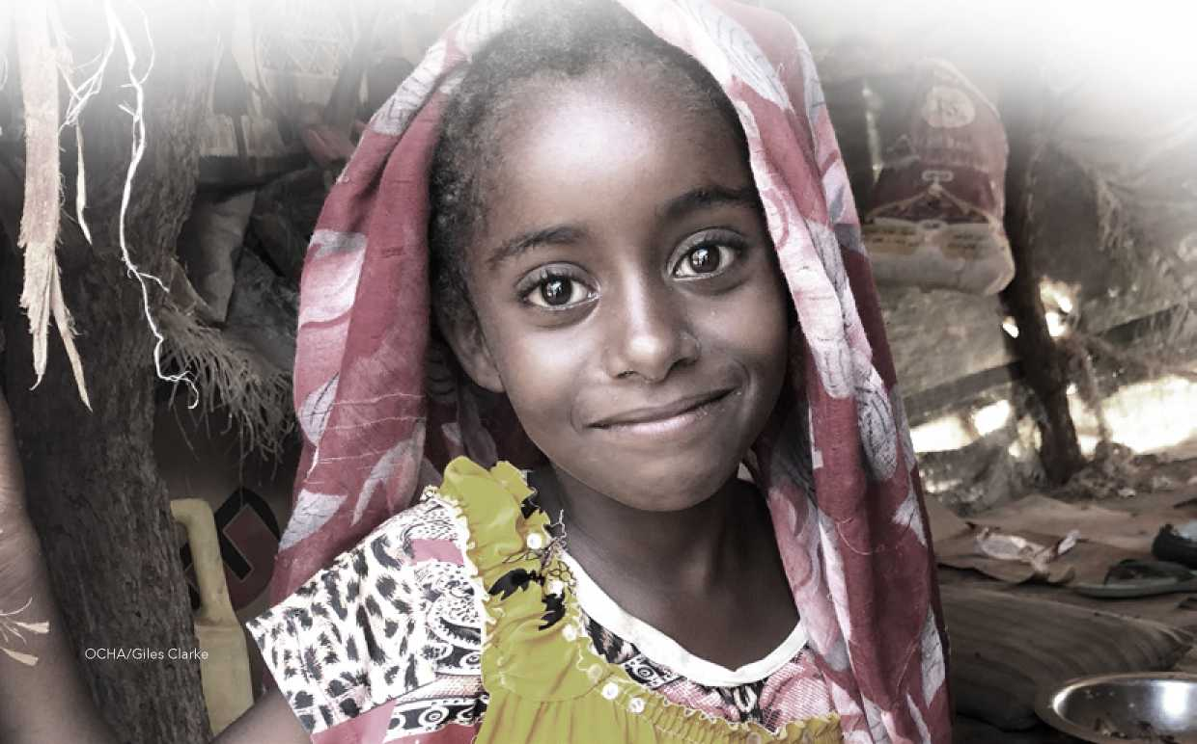

**HUMANITARIAN**

ACCeSS

As many as 6.5 million people, including 4.1 million who are in acute need, are currently living in 83 hard-to-reach districts where humanitarians face moderate or severe access constraints. Access to the 60 districts with moderate constraints and 23 districts with severe constraints is impacted by three main factors--conflict, bureaucratic impediments and logistics, which often overlap.

83 HARD-TO-REACH DISTRICTS

SEVERITY SCORE

| Low (250 districts)

H Medium (60 districts)

M High (23 districts) — Frontlines

**13**

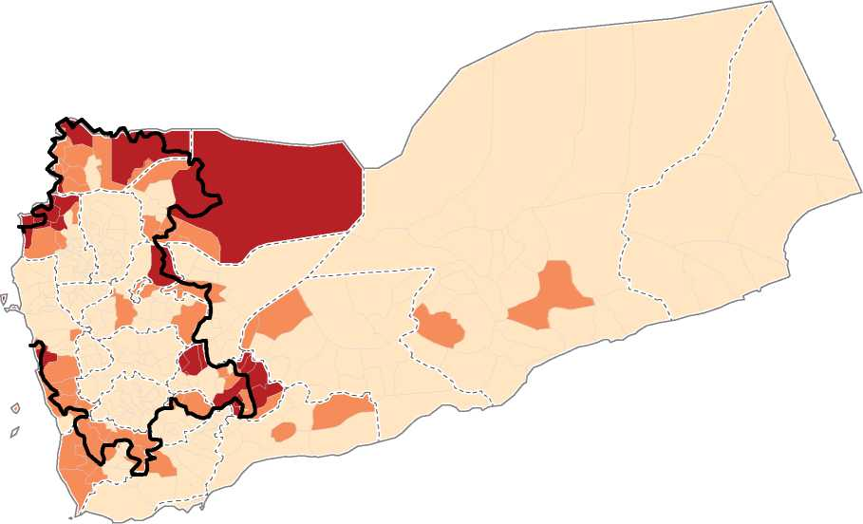

In 46 of the 83 hard-to-reach districts, access is predominantly impacted by conflict, including shifting front-lines. These districts account for 51 percent of the people living in hard-to- reach areas. In 33 districts, access is predominantly impacted by bureaucratic restrictions, including denial of visas and residency permits, denial of travel permits, delays in approving and clearing imports of essential equipment and refusal to sign sub-agreements. These districts account for 47 percent of the people living in hard-to-reach areas. In four districts, logistic constraints, including damaged or destroyed roads, difficult physical terrain, and seasonal weather are the main impediments to access. These districts account for two percent of the people living in hard-to-reach areas.

During 2019, humanitarian partners will be making major efforts during 2019 to expand and improve access. In areas where the main access impediments are conflict-related, civil liaison officers will be deployed to help open and structure the operating space. In areas where the main impediments are bureaucratic, partners will build on the Emergency Concept of Operations for Hodeida to introduce mutual accountability frameworks detailing the assessment, targeting, registration, implementation and monitoring arrangements for humanitarian activities. OCHA will also continue to track the status of all visa requests, travel permits, humanitarian imports and sub-agreements with the aim of strengthening advocacy and engagement with authorities.

On behalf of humanitarian partners, OCHA will continue to facilitate a number of system-wide mechanisms including the deconfliction protocols which help to ensure the safety of humanitarian staff, movements and operations in coordination with the Evacuation and Humanitarian Operations Committee (EHOC) in Riyadh. 'The OCHA team will maintain a list of more than 23,000 humanitarian sites protected under international humanitarian law and will continue to correlate access and severe vulnerabilities in high priority districts including the 45 districts with areas classified as IPC 5 and the 104 districts with the highest convergence of multiple, acute needs. In addition, OCHA will improve the existing access monitoring framework by introducing a new methodology to correlate access data with information on barriers, obstacles and impediments at the district-level.

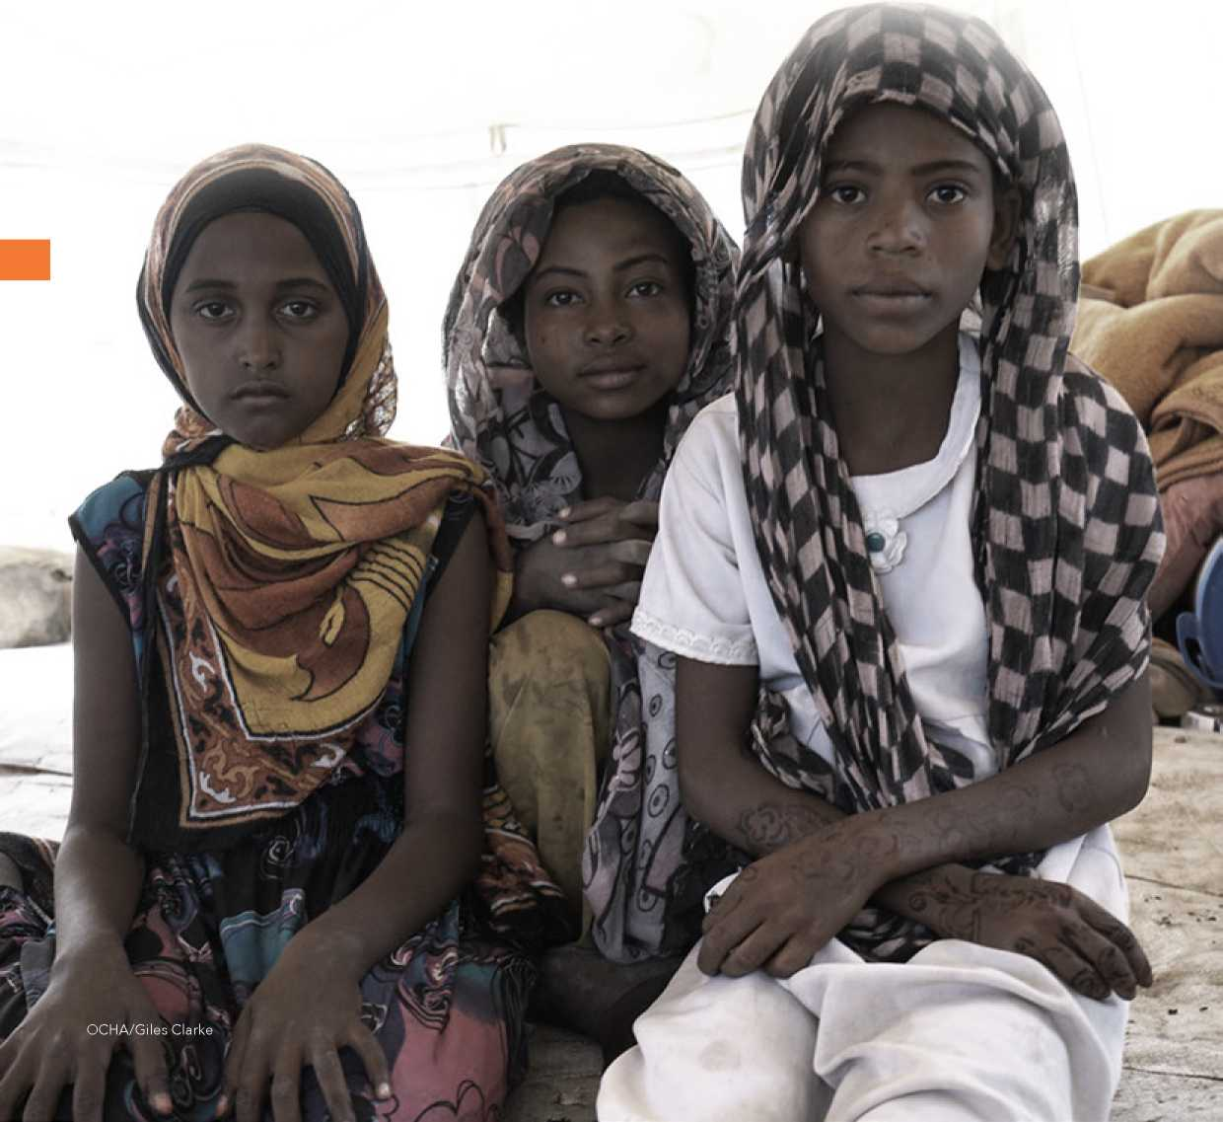

**14**

TARGeTING AND MONITORING

Recognizing the overriding importance of ensuring that assistance reaches the people most in need, every cluster has taken steps during 2018 to review, and where necessary, clarify the criteria used to identify beneficiaries. Clusters have also strengthened the mechanisms used during assessments, including protocols to help partners detect exclusion and inclusion errors. In a major step forward, the food security cluster and local authorities have agreed on a new beneficiary targeting mechanism and the expansion of biometric registration for the first time into northern areas. Committed to identifying irregularities of any kind and to taking corrective action based on evidence, humanitarian partners have established a framework for monitoring operations at multiple levels. This framework includes:

**15**

**Situation monitoring** which tracks developments and trends across the country that impact core humanitarian programming. In 2019, the majority of situation monitoring will be conducted by clusters, and in some cases, individual agencies. These efforts will be supported, where appropriate, by the UN’s Risk Mitigation Unit. Specific monitoring mechanisms will include, but are not limited to: Quarterly Integrated Phase Classification Updates including Famine Risk Monitoring in high-risk districts and SMART surveys conducted by the FSAC, nutrition and health clusters; weekly Disease Surveillance conducted by the health cluster; Monthly Market Monitoring conducted by WFP and FAO; Household WASH surveys conducted by the WASH cluster; and Annual Household-Level Multi-Cluster Location Assessment facilitated by OCHA, UNHCR and IOM.

**Response monitoring** which tracks the progressive steps being taken to reach the targets in each cluster strategy. During 2019, response monitoring will be conducted by cluster partners using relevant field tools to monitor output indicators. Clusters will report monthly to OCHA on the status of output targets, disaggregated by geographic area. OCHA will use these inputs to produce monthly 4W databases detailing humanitarian coverage across the country. Cluster inputs will be collated into monthly dashboards, mid-year and end-of-year Periodic Monitoring Report (PMR), issued in August 2019 and March 2020 respectively.

**Impact monitoring** which measures progress against the HRP’s five strategic objectives and the impact of each cluster’s first-line, second-line and full cluster responses. During 2019, cluster partners will use standardized methodologies to monitor a single impact indicator for each of the HRP’s five strategic objectives and for each of the 29 impact indicators across the 12 cluster strategies. To enable benchmarking, each indicator will include a baseline and annual target.

**HRP monitoring** which reinforces and cross-checks existing monitoring mechanisms. During 2019, HRP monitoring will be conducted by OCHA through an independent Third-Party Monitor. This specialized monitoring process will assess the accuracy of agency reporting by reviewing and comparing results with information contained in tracking documents. Using beneficiary interviews, physical observation and key informant interviews, Third Party Monitors will also verify the delivery of humanitarian assistance and supplies to intended beneficiaries and targeted facilities in selected districts.

**16**

**SUMMARY OF**

NeeDS, TARGeTS AND

ReqUIReMeNTS

PEOPLE IN NEED

PEOPLE IN ACUTE NEED

REQUIREMENTS (US$)

©24.1m

© 14.3m

|  |  |  |  |  |  |  |
| --- | --- | --- | --- | --- | --- | --- |
|  | **TOTAL** |  | | **TARGET** | **PARTNERS** | **REQUIREMENTS** |
|  | **People in need** | **People in acute need** | **% acute PiN** |  |  | **US$ million** |
| Food Security ® and Agriculture  Nutrition |  |  |  |  |  |  |
| 20.1M | 10M | 49% | 18.8M | 100 | 2,200 |
| 7.37M | 4.4M ■ | 71% | fl 5.97M | 38 | 320 | |
| Health | 19.7M | 14M | 71% | 15.8M | 71 | 627 ■ |
| Water, Sanitation *a* and Hygiene |  |  |  |  |  |  |
| 17.8M | 12.6M | 57% | fl 12.6M | 67 | 285 | |
|  |  |  |  |  |  |
| Protection  Shelter and Site  **T** Management  **m** Education  • • Refugees and  Migrants Multi-sector  **j** Rapid Response  **A\*** Mechanism  *Lo* Logistics  *Em* Emergency  B Telecommunications  Coordination | 14.4M | 8.2M | 79% | fl 4.8M | 48 | 153 | |
| 6.7M  4.7M  0.17M  1.9M | 4.5M ■  3.7M ■  0.17M |  1.9M I | 67%  60%  100%  100% | • 3M  • 2.7M  • 0.17M  • 1.9M | 90  69  17  22  90  38  254 | 222 |  105 |  122 |  49 |  69 |  5.5 |  26 1 |
| **TOTAL** | **24.1M** | **14.3M** | **59%** |  | **50%** | **$4.2bn** |



**PART II:**

**CLUSTER PLANS**

*//////////////^^^^*

***Fo* Food Security and Agriculture**

**4? Nutrition**

**T Health**

**Water, Sanitation and Hygiene**

**W Protection**

**# Shelter and Site Management**

**□□ Education**

**X Refugee and Migrant Multi-Sector**

***Ra* Rapid Response Mechanism**

***L* Logistics**

**Emergency Telecommunications**

***Co* Coordination**

**SUMMARY OF**

CLUSTeR ReSPONSe

PEOPLE IN NEED

M 20.1m

FOOD SECURITY AND  
AGRICULTURE

ACUTE NEED

Miom

PEOPLE  
TARGETED  
18.8m

ANNUAL  
REQUIREMENTS  
2.2bn

PARTNERS

100



CLUSTER OBJECTIVE

CLUSTER OBJECTIVE

Increase access to food for highly vulnerable families across the country

2

Increase household incomes and rehabilitate food security assets in areas with high levels of food insecurity

The food Security and Agriculture Cluster requires USD 2.2 billion for 2019. Of the 100 partners in the cluster, 54 are involved in first and second line responses

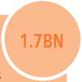

**FIRST LINE RESPONSE**

**18**

**SECOND LINE RESPONSE**

**491.4M**

Reduce severe hunger among highly vulnerable families by:

Distributing food, cash, or vouchers to severely food insecure families in IPC phase four districts and areas with populations in IPC phase five

Distributing food, cash, or vouchers to newly displaced and host families in high priority districts

Distributing conditional, and season-specific cash or vouchers and employing adults on public works schemes including projects that rehabilitate public infrastructure and community assets in IPC phase four districts and areas with populations in IPC phase five

Distributing agricultural and fishery kits to severely food insecure rural households in IPC phase four districts and areas with populations in IPC phase five

To measure first line impact, partners will particularly track the percentage increase in the number of targeted households with a food Consumption Score (fCS) greater than 42

Reduce severe hunger among vulnerable families by:

Distributing conditional, and season-specific cash or vouchers and employing adults on public works schemes including projects that rehabilitate public infrastructure and community assets in IPC phase three districts

Distributing drip irrigation kits and solar water pumps in IPC phase three districts

Restocking small ruminants and distributing beekeeping kits in IPC phase three districts

Supporting rural food processing and facilitating micro-enterprises in IPC phase three districts

Providing support to targeted households in IPC phase three districts to help establish micro businesses

TARGETING

Based on district-level famine Risk Monitoring (fRM) and Integrated Food Security Phase Classification (IPC) in all 333 districts, the food Security and Agriculture Cluster is targeting:

* 10 million severely food-insecure individuals in IPC phase four districts and areas with populations in IPC phase five will receive food, cash or vouchers each month
* 2 million newly displaced and host individuals in high priority districts will receive food, cash or vouchers each month
* 8 million severely food-insecure individuals in IPC phase four districts and areas with populations in IPC phase five will receive agricultural, livestock or fishery kits
* 1.5 million food insecure individuals in IPC phase four districts and areas with populations in IPC phase five will benefit from cash for work and employment in public works schemes
* 5.3 million food-insecure individuals in IPC phase three districts will receive conditional, and season-specific cash or vouchers and livelihoods support

During 2019, the cluster will build on its achievements which include:

* Distributing food, cash, or vouchers to an average of 4.2 million severely food-insecure individuals per month in IPC phase four areas
* Distributing food, cash, or vouchers to an average of 3.2 million severely food-insecure individuals per month in IPC phase three areas
* Distributing agricultural, livestock and fishery kits to 1.7 million severely food-insecure individuals in IPC phase four areas
* Distributing agricultural, livestock and fishery kits to 400,000 severely food-insecure individuals in IPC phase three areas
* Providing longer term livelihood support to 160,000 individuals in IPC phase three areas

To measure second line impact, partners will particularly track the percentage decrease in the number of households selling assets to buy food

CLUSTER OBJECTIVE

|  |  |  |  |  |
| --- | --- | --- | --- | --- |
|  | **X** *Pe* people in need **M** 7.4m |  | o |  |
| **NUTRITION** | O ACUTE NEED ™ 4.4m | PEOPLE TARGETED 6m | ANNUAL REQUIREMENTS 320m | PARTNERS  38 |

CLUSTER OBJECTIVE

Reduce the prevalence of and prevent acute malnutrition among children under five and pregnant and lactating women (PLw) and other vulnerable population groups

2

expand coverage of nutrition services and remove the barriers that prevent families from using them

The Nutrition Cluster requires USD 320 million for 2019. Of the 38 partners in the cluster, all are involved in first and second line responses

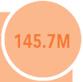

possible by:

**FIRST LINE RESPONSE**

**149.9M**

**24.**

**19**

Reduce acute malnutrition among highly vulnerable populations by:

Identifying and referring children and PLW with acute malnutrition to treatment programmes

Treating children suffering from severe acute malnutrition (SAM) with complications in therapeutic feeding centres

Providing financial support, including vouchers, to cover transport costs to treatment facilities for children suffering from SAM with complications

Providing food rations for care takers at treatment facilities Treating children with SAM at outpatient treatment programmes Treating children and PLW with moderate acute malnutrition (MAM) through targeted supplementary feeding programmes Providing counselling on feeding practices to PLW and caretakers Providing nutrition supplies and medicines

To measure first line impact, partners will particularly track the percentage decrease in the number of districts with critical acute malnutrition

SECOND LINE RESPONSE

Reduce micronutrient malnutrition among highly vulnerable populations by:

Providing blanket supplementary feeding programmes (BSfPs) to children under two and pregnant and lactating women in the 165 priority districts

Providing micronutrient supplements through Blanket BSfPs to children under two in 165 priority districts and multiple micronutrient powders to children over three in these districts and children under under-five in remaining districts

Deworming children under five

Providing vitamin A supplements to children aged under five years

Providing iron-folic acid supplements to PLW

Providing supplementary food to children under two in a phased approach across the country

Training partners on SMART surveys, assessments, information management and surveillance

Training frontline nutrition and health workers and community health volunteers on treatment protocols

establishing 80 health facility-based sentinel sites in districts at risk of famine and conducting SMART surveys in high-risk districts across 22 governorates

To measure second line impact, partners will particularly track the percentage increase in the number of children under-five receiving micronutrient powders

FULL CLUSTER RESPONSE

Reach as many children suffering from malnutrition as

* Increasing the number of TfCs from 83 to 120
* expanding the coverage of outpatient treatment programmes to 90 per cent and TSfPs to 80 per cent
* Conducting mass MUAC screening, deploying mobile teams, scaling up outreach and tracking case management and default rates in districts at risk of famine
* Providing WASh kits and testing and treating malaria among children suffering from acute and moderately acute malnutrition

To measure full cluster impact, partners will particularly track the percentage increase in coverage rates for inpatient and outpatient treatments and TSfPs

TARGETING

Based on 2018 SMART surveys and emergency food Security and Nutrition Assessments in 15 governorates, 2017 SMART surveys in three governorates, a 2016 SMART survey in one governorate and a 2016 emergency food Security and Nutrition Assessment in three governorates, the Nutrition Cluster is targeting as follows:

* Of the 357,487 children under five in need of SAM treatment, a minimum of 285,990 will benefit from support
* Of the 1.68 million children under five and 1.1 million PLW in need of TSfPs, a minimum of 937,878 children under five and 639,210 PLW will benefit from support
* Of the 800,719 children under two and 1,211,146 PLW in need of BSfPs, 100 per cent of the children and lactating women in need in 107 high-risk districts and 60 per cent in 58 new high-risk districts will benefit from support

During 2019, the cluster will build on its 2018 achievements which include:

* Supporting SAM programmes in 328 districts and MAM programmes in 276 districts, including, 83 TfCs, 3,605 Outpatient Therapeutic Programmes (OTP) and 3,028 TSfPs of which 2,806 provide OTPs and TSfPs in same sites, and 194 mobile teams
* Screening and referring 1,665,950 boys and 1,708,034 girls under five for treatment of acute malnutrition
* Treating 345,463 severely acutely malnourished children under five with or without complications 558,386 moderately acutely malnourished children under five and 402,845 PLW with acute malnutrition
* Providing counselling and messaging on feeding practices to 1,778,853 pregnant women and caretakers of children under two years.
* Providing 855,054 children under two with multiple micronutrient powders and 3,424,667 children with vitamin A
* Deworming 738,865 children and providing 1,191,017 pregnant women with iron-folic acid supplements

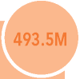help provide the core components of the Minimum Service Package (MSP) in high priority districts by:

HEALTH

PEOPLE IN NEED

19.7m

ACUTE NEED

14m

PEOPLE  
TARGETED  
15.8m

ANNUAL  
REQUIREMENTS

PARTNERS

627m

71

**FIRST LINE RESPONSE**

Procuring, pre-positioning and providing essential medicines and supplies to health units, health centres and hospitals

Providing general service and trauma care, communicable disease prevention and control, the Minimum Initial Service package for reproductive health and inpatient care for people suffering from Severe Acute Malnutrition

Providing specialized care for cancer and renal failure

Vaccinating vulnerable groups against oral cholera vaccines (OCV), measles, oral polio vaccine (OPV) and diphtheria

establishing a medical air bridge for patients suffering from conditions that cannot be treated inside Yemen

* Providing emergency training, fuel, water and incentives for health staff

To measure first line impact, partners will particularly track the percentage decrease in the number of reported cases of cholera

**20**

help ensure that highly vulnerable people have access to an expanded range of health services in high priority districts by:

**SECOND LINE RESPONSE**

**72.2M**

Supporting all additional components of the Minimum Service Package including child and maternal health care, non­communicable disease prevention and care, mental health and psychosocial services

Upgrading vaccination programmes, including cold chain equipment, operational support, training and social mobilization

To measure second line impact, partners will particularly track the percentage increase in the number of targeted health facilities providing the Minimum Service Package

61.5M

FULL CLUSTER RESPONSE

help strengthen health systems and infrastructure in high priority districts by:

Training doctors, nurses and midwives

Renovating, rehabilitating and equipping non-functional health facilities in high priority districts

Upgrading drug supply and health information systems

Upgrading rehabilitation centres for war-wounded

CLUSTER OBJECTIVE

Improve access to primary, secondary and tertiary health care including district hospitals in priority districts

CLUSTER OBJECTIVE

2

help ensure that health facilities in priority districts are able to respond to epidemics and outbreaks

CLUSTER OBJECTIVE

3

help restore functionally of the closed or damaged health facilities in high priority districts

The health Cluster requires USD 627 million in 2019. Of the 71 partners in the cluster, 50 are involved in first and second line responses

TARGETING

Based on health Resources Availability Mapping (heRAMS), the MCLA and other assessments in 22 governorates, the health Cluster is targeting as follows:

* Of the 611,330 children under one in need of immunization, 580,765 will benefit from support
* Of the 4,930,086 women of child bearing age in need of comprehensive obstetric care, 3,944,068 will benefit from support
* Of the 788,814 pregnant women in need of skilled attendants at delivery, 378,630 will benefit from support
* Of the 19,720,344 people in need of at least one consultation per person per year, the 15,776,275 will benefit from support

During 2019, the cluster will build on its 2018 achievements which include:

* Providing health consultations to 11.8 million people
* Providing immunization services to 541,715 children
* Treating 31,620 trauma patients with medical care at the hospitals
* Assisting 223,000 women during deliveries
* Providing antenatal and postnatal care to 1.2 million women
* Providing clinical care to 992 survivors of sexual and gender-based violence
* Training 12,800 health staff on the Minimum Service Package, 1,650 midwives on reproductive health, and 12,000 community health workers and volunteers on hygiene promotion and disease prevention

To measure full cluster impact, partners will particularly track the percentage increase in the number of targeted people benefitting from the MSP at all levels of care in priority districts

|  |  |  |  |  |  |
| --- | --- | --- | --- | --- | --- |
| % A  **WATER, SANITATION**  **AND HYGIENE** |  | PEOPLE IN NEED  17.8m | X * Z | o  ANNUAL REQUIREMENTS 285m |  |
| **M** | ACUTE NEED  12.6m | PEOPLE TARGETED 12.6m | PARTNERS  67 |

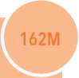

**21**

FIRST LINE RESPONSE

help ensure newly displaced families in high-risk areas have access to safe drinking water and sanitation services by:

* Providing fuel and disinfecting agents and repairing public water supply systems
* Trucking water and providing storage containers at communal and household levels
* Providing filters and chlorine tablets to at-risk households
* Monitoring water quality at household and grid level
* Providing operational support and maintenance to sanitation systems in at-risk areas
* Constructing and desludging communal emergency latrines
* Distributing basic hygiene kits and cholera kits
* Messaging on safe hygiene practices in high risk areas
* Conducting emergency cleaning campaigns

To measure first line impact, partners will particularly track the percentage decrease in the number of reported cases of water borne disease, including cholera

73M

SECOND LINE RESPONSE

expand water and sanitation services for displaced families and vulnerable host communities in priority districts by:

* Rehabilitating public water systems and promoting water quality surveillance and monitoring
* expanding the number of water facilities receiving fuel and operational support
* expanding the number of sanitation facilities receiving fuel and operational support and maintenance
* expanding the number of households receiving water storage containers
* Rehabilitating and desludging household latrines
* Supporting solid waste collection and disposal
* Building the capacity of local WASh partners and conducting cleaning campaigns

To measure second line impact, partners will particularly track the percentage increase in the number of people in acute need with access to safe water and sanitation services

50M

FULL CLUSTER RESPONSE

help maintain the functionality of water and sanitation systems by:

* Improving and augmenting water supply, treatment and quality surveillance systems
* Building the institutional capacity of local water and sanitation authorities
* Improving and upgrading sanitation systems
* Installing waste collection and disposal systems in targeted municipalities
* Promoting hygiene awareness

To measure full cluster impact, partners will particularly track the percentage increase in the number of upgraded water and sanitation systems

CLUSTER OBJECTIVE

Provide emergency water sanitation and hygiene services and assistance to highly vulnerable people

CLUSTER OBJECTIVE

2

Restore and maintain sustainable water and sanitation systems, particularly in high-risk areas

The wASh Cluster requires USD 285 million for 2019. Of the 67 partners in the cluster, all are involved in first and second line responses

TARGETING

Based on the WASh household Assessment, MCLA, SMART surveys, and eDews morbidity data, the WASh Cluster is targeting as follows: • 10.7 million people will benefit from improved public water systems

* 5.5 million people will benefit from improved public sanitation systems
* 4.8 million people will benefit from emergency water supplies
* 1.1 million people in 102 pre-famine districts will benefit from sanitation services
* 4.1 million people in 192 cholera risk districts will receive adequate safe drinking water
* 7.2 million people will access hygiene items and awareness

During 2019, the cluster will build on its 2018 achievements which include:

* Supporting public water supply systems facilities benefitting 7.9 million people
* Supporting public sanitation facilities benefitting 3.9 million people
* Providing key hygiene items to 6.7 million people
* Dispatching rapid reaction teams in response to 140,000 cholera alerts
* Providing emergency water supplies to 1.3 million displaced people
* Providing emergency sanitation to 900,000 people

CLUSTER OBJECTIVE

|  |  |  |  |  |
| --- | --- | --- | --- | --- |
| w  **PROTECTION** | **A** *Pe* people in need ™ 14.4m  **O** ACUTE NEED ™ 8.2m | PEOPLE TARGETED 4.8m | o  ANNUAL REQUIREMENTS 153m | PARTNERS  69 |

CLUSTER OBJECTIVE

Provide specialized assistance to people with specific protection needs, including the victims of violence

2

Support community centres, programmes and protection networks

The Protection Cluster requires USD 153 million for 2019. All of the 69 partners in the cluster are involved in first and second line responses

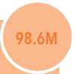

**FIRST LINE RESPONSE**

**22**

help address the immediate protection needs of highly vulnerable people by:

Identifying and referring people with specific needs, including women, children, the elderly and people living with disabilities to service providers

Assisting people without documentation and referring them to appropriate authorities

Distributing cash assistance to people and households at extreme risk

Distributing family, transit and dignity kits

Releasing contaminated land, disposing unexploded ordnance and raising awareness of risks posed by mines

To measure first line impact, partners will particularly track the percentage increase in the number of at-risk people who receive protection assistance or specialized services

50.9M

SECOND LINE RESPONSE

facilitate the work of community-level solidarity initiatives by:

Training community volunteers and service providers on safety, conflict resolution and prevention of violence

Supporting community programmes, including skills and livelihood initiatives, for the victims of violence

To measure second line impact, partners will particularly track the percentage increase in the number of volunteers trained

3.5M

FULL CLUSTER RESPONSE

help communities prevent and address protection issues by:

* Building the capacity of national, district and community partners and institutions to promote safety, support survivors of violence, and help resolve local level disputes

To measure full cluster impact, partners will particularly track the percentage increase in the number of priority communities where specialized services are available

TARGETING

Based on severity and the MCLA in 22 governorates, the Protection Cluster is targeting as follows:

* 187,622 people with specific needs, including women, children, the elderly, people living with disabilities, and victims of violence, will benefit from specialized services
* 115,358 people will receive protection cash assistance
* 140,101 family, transit and dignity kits will be distributed
* 1.7 million people will benefit from mine risk awareness
* 10 million square meters of contaminated land will be released
* 14,500 community volunteers and service providers will receive training on conflict resolution, resilience, safety and prevention of violence
* 2.5 million people will benefit from community programmes and initiatives

During 2019, the cluster will build on its 2018 achievements which include:

* Identifying, referring and providing specialized services for more than 142,135 people with specific needs, including women and children
* Providing more than 60,133 households with protection cash assistance
* Distributing more than 120,350 family, transit and dignity kits
* Providing mine risk education to more than 2.1 million people
* Surveying and clearing more than 6.3 million square meters of land
* Training more than 13,643 community volunteers and service providers
* Supporting community programmes and initiatives for more than 1.1 million persons

CLUSTER OBJECTIVE

|  |  |  |  |  |
| --- | --- | --- | --- | --- |
| **SHELTER AND SITE MANAGEMENT** | **A** *Pe* people in need ™ 6.7m  |A ACUTE NEED  M 4.5m | PEOPLE TARGETED 3m | ANNUAL REQUIREMENTS 222m | PARTNERS  90 |

CLUSTER OBJECTIVE

Provide safe, appropriate shelter and essential household items to displaced and highly vulnerable families

2

Coordinate the delivery of a Minimum Service Package (MSP) in under-served emergency and IDP settlements

The Shelter and Site Management Cluster requires USD 222 million for 2019. Of the 90 partners in the cluster, 61 are involved in first and second line responses

**23**

FIRST LINE RESPONSE 206M

Provide immediate emergency supplies to newly displaced families and help ensure basic services are available at under-served IDP settlements by:

* Distributing household and emergency shelter kits and where appropriate, winterization grants
* Identifying gaps in the delivery of basic services in under-served emergency and IDP settlements sites and coordinating with partners and local committees to cover these
* Providing rental subsidies and where appropriate cash grants to rehabilitate damaged houses
* Constructing and rehabilitating transitional shelters in areas where families require protection and additional support

To measure first line impact, partners will particularly track the percentage increase in the number of under-served IDP settlements where the MSP is available

2M

SECOND LINE RESPONSE

help upgrade living conditions for families living in IDP settlements and transitional shelter arrangementsby:

* Providing maintenance support and shelter upgrades

To measure second line impact, partners will particularly track the percentage increase in the number of families benefitting from an upgraded shelter

14M

FULL CLUSTER RESPONSE

Increase the sustainability of shelter arrangements by:

* Providing cash grants to reconstruct damaged houses

To measure full cluster impact, partners will particularly track the percentage increase in the number of returnees living in adequate housing

TARGETING

Based on Site Management Baseline Assessments in 1,200 sites, and the MCLA, the Shelter and Site Management Cluster is targeting as follows:

* 489 IDP settlements in 39 districts in 12 governorates will receive MSPs
* 941,000 people in 177 districts in 21 governorates will receive household kits, 491,000 people in 157 districts in 19 governorates will receive emergency shelter kits (eSKs) and 412,000 people in 110 districts in 18 governorates will receive winterization cash grants
* 598,000 people in 140 districts in 20 governorates will receive rental subsidies and 150,000 people in 140 districts in 14 governorates will receive household cash grants
* 125,000 people in 110 districts in 18 governorates will receive cash grants to rehabilitate damaged houses
* 84,000 people in 76 districts in 17 governorates will be housed in transitional shelters and 107,000 people in 39 districts in 12 governorates will receive maintenance support

During 2019, the cluster will build on its 2018 achievements which include:

* Distributing household kits to 554,000 people and cash grants to 29,000 people for household items
* Distributing eSKs to 136,000 people and cash grants to 13,000 people for emergency shelter
* Distributing rental subsidies to 380,000 people
* Distributing winterization kits to 46,000 people and cash grants to 15,000 people
* Distributing cash grants to 830 people to rehabilitate 120 damaged houses
* Constructing transitional shelters for 11,000 people

EDUCATION

PEOPLE IN NEED

4.7m

ACUTE NEED

3.7m

PEOPLE  
TARGETED  
2.8m

o

ANNUAL  
REQUIREMENTS  
105m

PARTNERS

48



CLUSTER OBJECTIVE

help maintain basic education services, particularly in areas where schools are damaged, closed or unable to fully operate because of budget, payroll and other conflict-related constraints

The education Cluster requires USD 105 million in 2019. Of the 48 partners in the cluster, 30 are involved in first line response

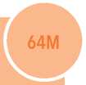

**FIRST LINE RESPONSE**

**TARGETING**

**24**

help ensure schools remain open and operational by:

Providing allowances for unpaid teachers

Providing schools meals to boys and girls

establishing Temporary Learning Classrooms (TLCs) for displaced children

Distributing kits, texts, hygiene materials, furniture and supplies to targeted schools

Providing specialized child-centered programmes in hard-hit areas

facilitating national exams

To measure first line impact, partners will particularly track the percentage increase in the number of functional schools

Based on the MCLA, Task force for Population Movember (TfPM) figures, Ministry of education (MoE) enrolment records and field data, the Education Cluster is targeting as follows:

142,000 unpaid teachers in 11 governorates will receive allowances 63,500 children will benefit from Temporary Learning Spaces (TLSs) 1,500,000 children will benefit from education supplies 950,000 children will receive school meals

795, 000 children will benefit from specialized child-centered programmes

394,000 children will benefit from rehabilitated schools

During 2019, the cluster will build on its 2018 achievements which include:

33M

SECOND LINE RESPONSE

help restore damaged and destroyed schools by:

Rehabilitating buildings, including WASh facilities

Training specialized education staff on emergency data collection and analysis

To measure second line impact, partners will particularly track the percentage increase in the number of children remaining in formal education

Rehabilitating 1,193 schools benefitting 417,819 children

Providing meals to 432,521 children

Distributing education supplies benefitting 171,299 children

Providing specialized programmes for 181,430 children

Providing TLCs for 48,868 children

Providing specialized services benefiting 463,856 children

8.4M

FULL CLUSTER RESPONSE

help strengthen teaching and the management of schools and education services by:

• Training teachers, school managers, supervisors and family councils

To measure full cluster impact, partners will particularly track the percentage increase in the number of teachers teaching on at least 80 per cent of school days

REFUGEE AND MIGRANT  
MULTI-SECTOR

PEOPLE IN NEED

170k

ACUTE NEED

170k

PEOPLE  
TARGETED  
170k

ANNUAL  
REQUIREMENTS  
122m

PARTNERS

17



CLUSTER OBJECTIVE

CLUSTER OBJECTIVE

facilitate durable solutions including Assisted Spontaneous Return (ASR) and voluntary humanitarian Return (vhR) programmes

2

Provide life-saving, multi-sectoral assistance and specialized support to refugees, asylum-seekers and migrants with acute needs

Refugee and migrant partners require USD 122 million for 2019. All of the 17 partners in the sector are involved in first and second line responses

**FIRST LINE RESPONSE**

**91M**

**25**

Provide, in coordination with authorities, life-saving assistance to vulnerable refugees, asylum-seekers and migrants by:

facilitating voluntary return of refugees and migrants to their countries of origin

Distributing food assistance and drinking water

Delivering critical health, WASh and shelter services

Distributing direct assistance

Registering and documenting new arrivals

To measure first line impact, partners will particularly track the number of persons who have voluntarily returned to their countries of origin

30.5M

SECOND LINE RESPONSE

Provide, in coordination with authorities, specialized services for women at risk, pregnant and lactating women, the elderly, unaccompanied minors, people living with serious medical conditions and people with disabilities by:

TARGETING

Based on the MCLA, the Protection Baseline Assessment and the Displacement Tracking Matrix, the Refugees and Migrants Multi­Sector (RMMS) is targeting as follows:

* Of the 422,355 refugees, asylum-seekers and migrants estimated to be in Yemen, 170,000 will receive some form of assistance

During 2019, partners will build on their 2018 achievements which include:

* Reaching 180,000 targeted people with support
* facilitating the voluntary return of 3,548 refugees and migrants to their countries of origin
* Providing shelter to 8,487 refugees in Kharaz camp in Lahj governorate
* Providing life-saving medical assistance to 87,769 refugees, asylum-seekers and migrants, cash assistance to 6,551 refugees, asylum-seekers, and education support to 10,997 refugees and host community children
* Registering 31,848 migrants in order to access returns, basic services and other assistance

Referring highly vulnerable children including unaccompanied children and children with disabilities to specialized services facilitating education at locations agreed with the authorities helping to build the capacity of coastal authorities and registration

agencies and stakeholders, including at the community level

To measure second line impact, partners will particularly track the percentage increase in the number of targeted people that have benefited from at least one form of specialized assistance

|  |  |  |  |  |
| --- | --- | --- | --- | --- |
| *&*  **RAPID RESPONSE MECHANISM** | *Pe p* people in need  WIT 1.9m  O ACUTE NEED m 1.9m | PEOPLE TARGETED  1.9m | ANNUAL REQUIREMENTS 49m | PARTNERS  22 |

CLUSTER OBJECTIVE

Provide immediate, life-saving emergency assistance to families who are newly displaced and in hard-to reach areas and to destitute returnees

The Rapid Response Mechanism (RRM) requires USD 49 million for 2019. All of the 22 partners in the RRM are involved in the first-line response

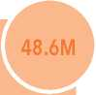

cash assistance to families who are on the move, in hard-to-reach

**26**

FIRST LINE RESPONSE

Distribute immediate, life-saving emergency supplies and

areas, returning to their homes, caught at checkpoints or stranded close to the front lines by:

* Pre-positioning supplies in mobile storage units and safe, accessible sites
* Activating teams and distributing RRM Kits (immediate response rations (IRR), basic hygiene kits and dignity kits)within 72 hours of receiving and verifying information on the movement and location of displaced people
* Providing multi-purpose cash assistance (MPCA) and other support including shelter kits, non-food items and hygiene supplies to newly displaced persons for 1-3 months following rapid verification and needs assessments
* facilitating rapid needs assessments as soon as first distributions are over to trigger first-line and second-line cluster responses

TARGETING

Based on emergency Displacement Tracking and the Initial Situation Tool assessment, the RRM is targeting as follows:

* 1.2 million newly displaced persons will receive RRM kits
* 750,000 highly vulnerable returnees identified through registration centers will receive RRM kits
* 480,000 most vulnerable IDPs will be benefit from cash grants and other support including shelter kits, non-food items and hygiene supplies

During 2019, partners will build on their 2018 achievements which include:

* Distributing 167,000 RRM kits to 1,002,000 people
* Providing MPCA to more than 28,000 households
* Distributing RRM Kits to the most destitute returnees within 72 hours of receiving information on the location of those returnees

To measure first line impact, partners will particularly track the percentage increase in the number of newly displaced IDP and returnee households receiving RRM kits



LOGISTICS

ANNUAL REQUIREMENTS

69m

PARTNERS

90

CLUSTER OBJECTIVE

Provide a full-range of logistics support and services including cargo and passenger transport and storage to humanitarian partners throughout the country

The Logistics Cluster requires USD 69 million for 2019. Of the 90 partners in the cluster, all are involved in first and second line responses

**27**

FIRST LINE RESPONSE 58.5*

Support humanitarian operations across Yemen by:

* facilitating cargo transport by air and sea to Ye men, and by land within the country
* facilitating temporary storage within Yemen
* Providing passenger sea transport between Djibouti and Aden
* Providing cargo and passenger air transport through UNhAS between Sana’a, Aden, Djibouti and Amman
* Managing a revolving fuel facility and providing diesel to health and WASh facilities and key electricity systems that support civilian infrastructure

To measure first line impact, partners will particularly track the percentage increase in the number of humanitarian organizations using common logistics services

10M

SECOND LINE RESPONSE

facilitate the delivery of life-saving humanitarian cargo and supplies into high priority districts by:

* Rehabilitating key sections of Al hudaydah port and expanding logistics infrastructure at high volume entry points including Sana’a and Aden
* Acquiring equipment to increase cargo-handling capacity

To measure second line impact, partners will particularly track the percentage increase in volume of cargo handling capacity at key entry points

TARGETING

Based on partner surveys, the Logistics Cluster is targeting as follows:

* 10,000 metric tons (MTs) of relief supplies will be transported
* 10,000 MTs of relief supplies will be stored
* 500 passengers will be transported by sea
* 12,000 passengers will be transported by air
* 40 million liters of diesel will be distributed to health and WASh facilities

During 2019, the cluster will build on its 2018 achievements which include:

* Transporting 12,078 passengers from 72 organizations on UNhAS flights and carrying out 40 medical evacuations (medevacs)
* Transporting 537 passengers from 26 organizations on WfP chartered vessels
* Transporting 2,431 MT of cargo by sea, 1,079 MT by air, and 13,647 MT cargo by road
* Storing 15,500 MT in Al hudaydah, Aden and Sana’a on behalf of 17 organizations
* Providing 27,410,412 liters of diesel to health centres, water corporations and vaccination centres

EMERGENCY

TELECOMMUNICATIONS

ANNUAL REQUIREMENTS

5.5m

PARTNERS

38



CLUSTER OBJECTIVE

Provide emergency telecommunications services to humanitarian partners throughout the country

The emergency Telecommunications Cluster (eTC) requires USD 5.5 million in 2019

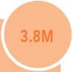

**FIRST LINE RESPONSE**

**28**

Provide reliable communications services for humanitarian partners by:

* establishing, equipping and maintaining emergency telecommunications hubs establishing stand-by agreements with local service providers

Providing specialized telecommunication services for the Al Hudaydah response

To measure first line impact, partners will track the percentage increase in the number of users reporting favourably on eTC services

1.7M

SECOND LINE RESPONSE

Upgrade and expand telecommunications services for humanitarian partners by:

TARGETING

Based on eTC assessments in five hubs, the eTC is targeting as follows:

* 38 partners including 22 NGOs and 16 UN agencies will benefit from eTC services in Sana’a, Al hudaydah, Ibb, Aden, Sa’ada, Mukalla, Al Mukha, and Al Turba

During 2019, the cluster will build on its 2018 achievements which include:

* establishing and maintaining 25 emergency Operations Centres for the cholera response
* Opening six new eTC Internet connectivity hubs in Al hudaydah, Sa’ada, and Aden
* Upgrading network infrastructure in Ibb and Al hudaydah hubs
* establishing an eTC helpdesk in Sana’a
* Providing IT capacity building for staff

expanding service desks to the field

Providing in-country and global training for national staff and service providers

Rehabilitating and upgrading communications centers and hubs

To measure second line impact, partners will particularly track the percentage increase in the number of critical incidents reported to eTC helpdesks and resolved within 24 hours



COORDINATION

ANNUAL REQUIREMENTS

26m

PARTNERS

254

CLUSTER OBJECTIVE

facilitate principled evidence-based humanitarian planning, action and advocacy

The Coordination Cluster requires USD 26 million for 2019

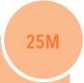

**29**

FIRST LINE RESPONSE

facilitate core coordination capacities and competencies by:

* Providing secretariat support to the humanitarian Coordinator and Humanitarian Country Team
* Providing all possible forms of direct support to clusters and facilitating inter-cluster mechanisms
* facilitating the humanitarian programme cycle including assessments, humanitarian Needs Overview (hNO) and the humanitarian Response Plan (hRP)
* facilitating the work of operational hubs including common datasets
* establishing and facilitating appropriate emergency modalities and mechanisms including emergency concepts of operation (eCOO) and an emergency Operations Room (eOR)
* Providing all possible support to expand access and create an enabling operational environment
* facilitating civil-military liaison, including de-confliction mechanisms
* Managing the Yemen humanitarian fund (Yhf)
* Identifying and promoting concrete steps to improve accountability to affected populations
* Tracking contributions to the humanitarian operations and setting standards for donor reporting
* Coordinating third party monitoring

To measure first line impact, partners will particularly track the percentage increase in the number of regularly accessible areas

1M

SECOND LINE RESPONSE

facilitate increased roles for national NGOs and the private sector in humanitarian operations by:

* engaging with businesses, transporters, charities and endowments
* Building the technical capacities of national NGOs

To measure second line impact, partners will particularly track the percentage increase in the number of national partners receiving funding through the HRP

TARGETING

Based on partner surveys, the Coordination Cluster is targeting as follows:

* All counterparts involved in the humanitarian operation will receive regular updates and situation analysis
* All humanitarian partners involved in the cluster system will receive timely support
* All donors contributing to the operation will receive timely information

During 2019, the cluster will build on its 2018 achievements which include:

* Disseminating six bi-monthly humanitarian dashboards, 15 humanitarian snapshots, seven funding snapshots, nine 3W dashboards, 44 humanitarian updates, 19 access alerts, and 17 situation reports
* Disseminating interactive dashboards on needs, plans and responses on relevant websites
* Developing a country-wide preparedness plan
* facilitating the sequencing and prioritization of the 2018 hRP
* facilitating the Multi-Cluster Location Assessment (MCLA) in 6,791 locations across the country
* establishing an eOR for Al huydaydah and facilitating the elaboration of an eCOO
* facilitating the Rapid Response Mechanism (RRM)
* facilitating major block grants to the hRP
* facilitating two reserve and one standard allocations of the Yhf for 72 partners
* Publishing regular public updates and sitreps on the humanitarian situation

**PART III: ANNEX**

*/////////////////^^^^*

**Strategic Objectives, indicators and targets**

**STRATEGIC OBJECTIVES**

INDICATORS, AND TARGeTS

**2019 YHRP STRATEGIC OBJECTIVES**

| **STRATEGIC OBJECTIVE** | **IMPACT INDICATOR** | **2018 BASELINE** | **2019 TARGET** |
| --- | --- | --- | --- |
| SO1: Help millions of destitute Yemenis overcome hunger | Percentage decrease in the number of IPC phase 4 districts and areas with populations in IPC phase 5 | 190 districts | 150 districts (20% reduction) |
| SO2: Prevent large-scale outbreaks of cholera and infectious diseases | Percentage decrease in the number of outbreaks of cholera and infectious diseases | 192 districts | 172 districts  (10% reduction) |
| SO3: Promote the dignity of displaced families living in emergency, transit and hosting sites | Percentage increase in the number of IDP sites where the minimum service package is provided | 0% | 45% |
| SO4: Reduce the risk of displacement and violence against civilians and facilitate the recovery of people traumatized by the conflict | Percentage decrease in the number of incidents with civilian impact | 36.5% | 32.9% |
| SO5: Preserve the capacity of public sector institutions to deliver life-saving basic services | Percentage of humanitarian assistance provided through public sector institutions | 15% | 35% |

**31**

**CLUSTER IMPACT INDICATORS**

**Food Security and Agriculture**

|  |  |  |  |  |
| --- | --- | --- | --- | --- |
| **RESPONSE TYPE** | **INDICATORS** | **BASELINE** | **TARGET** | **REQUIREMENTS ($)** |

|  |  |
| --- | --- |
| First Line Response | Percentage of targeted households with Food 33% 50% $1.7 billion  Consumption Score (FCS) greater than 42 |
| Second Line Response | percentage decrease in the number of 31% 16% $491.4 million  households selling assets to buy food |

| Percentage increase in coverage rates for inpatient and outpatient treatments and targeted supplementary feeding programmes. | "90 % for SAM without "95% for SAM without $24.7 million  complications; 30% SAM complications; 60% for  with complications; SAM with complications;  38% for MAM " 62% for MAM " |
| --- | --- |

**Nutriton**

|  |  |  |  |  |
| --- | --- | --- | --- | --- |
| **RESPONSE TYPE** | **INDICATORS** | **BASELINE** | **TARGET** | **REQUIREMENTS ($)** |
| First Line Response | Percentage decrease in the number of districts with critical acute malnutrition | 91 districts | 45 district  (50% decrease) | $145.7 million |
| Second Line Response | Percentage increase in the number of children under-five receiving micronutrient powders | 48.6% | 60% | $149.9 million |

Full Cluster

**Health**

|  |  |  |  |  |
| --- | --- | --- | --- | --- |
| **RESPONSE TYPE** | **INDICATORS** | **BASELINE** | **TARGET** | **REQUIREMENTS ($)** |
| First Line Response | Percentage decrease in the number of reported cases of cholera | 369,900 cases | 295,200 cases (20% reduction) | $493.5 million |
| Second Line Response | Percentage increase in the number of targeted health facilities providing the Minimum Service Packages (MSP) | 1,400 health facilities | 1,820 health facilities (30% increase) | $72.2 million |
| Full Cluster Response | Percentage increase in the number of targeted people benefitting from the Minimum Service Package at all levels of care in priority districts | 8 million | 10.4 million (30% increase) | $61.5 million |

**Water, Sanitation and Hygiene (WASH)**

|  |  |  |  |  |
| --- | --- | --- | --- | --- |
| **RESPONSE TYPE** | **INDICATORS** | **BASELINE** | **TARGET** | **REQUIREMENTS ($)** |
| First Line Response | Percentage decrease in the number of outbreaks of infectious diseases, including cholera | 369,000 cases | 295,200 cases (20% reduction) | $162 mil |
| Second Line Response | Percentage increase in the number of people in acute need with access to safe water and sanitation services | 12.6 million in acute need | 11 million (14% reduction) | $73 mil |
| Full Cluster Response | Percentage increase in the number of upgraded water and sanitation systems | 522 | 1,247  (138% increase) | $50 mil |

**Protection**

**32**

| **RESPONSE TYPE** | **INDICATORS** | **BASELINE** | **TARGET** | **REQUIREMENTS ($)** |
| --- | --- | --- | --- | --- |
| First Line Response | Percentage increase in the number of at-risk people who receive protection assistance or specialized services | 36% | 26% | $ 98.6 million |
| Second Line Response | Percentage increase in the number of volunteers trained | 17% | 30% | $ 50.9 million |
| Full Cluster Response | Percentage increase in the number of priority communities where specialized services are available | 93% | 93% | $ 3.5 million |

**Education**

|  |  |  |  |  |
| --- | --- | --- | --- | --- |
| **RESPONSE TYPE** | **INDICATORS** | **BASELINE** | **TARGET** | **REQUIREMENTS ($)** |
| First Line Response | Percentage increase in the number of functional schools | 35% | 60% | $64 million |
| Second Line Response | Percentage increase in the number of children accessing and remaining in formal education | 75% | 80% | $33 million |
| Full Cluster Response | Percentage of teachers actively teaching at least 80% of school days | 65% | 70% | $8.4 million |

**Shelter and Site Management**

|  |  |  |  |  |
| --- | --- | --- | --- | --- |
| **RESPONSE TYPE** | **INDICATORS** | **BASELINE** | **TARGET** | **REQUIREMENTS ($)** |
| First Line Response | Percentage increase in the number of under­served collective sites where the minimum service package is available | 11% | 51% | $206 million |
| Second Line Response | Percentage increase in the number of families benefitting from upgraded shelter | 0% | 36% | $2 million |
| Full Cluster Response | Percentage increase in the number of returnees living in adequate housing | 1% | 10% | $14 milion |

Refugees and Migrants Multi-Sector (RMMS)

|  |  |  |  |  |
| --- | --- | --- | --- | --- |
| **RESPONSE TYPE** | **INDICATORS** | **BASELINE** | **TARGET** | **REQUIREMENTS ($)** |
| First Line Response | Number of persons of concern who returned to their countries of origin | 3,548 | 13,000  (266% increase) | $91 million |
| Second Line Response | Percentage of persons of concern that benefited from at least one form of specialized assistance | 2,223 | 10,256  (361% increase) | $30.5 million |

* reflects january - November 2018 estimation

Rapid Response Mechanism (RRM)

|  |  |  |  |  |
| --- | --- | --- | --- | --- |
| **RESPONSE TYPE** | **INDICATORS** | **BASELINE** | **TARGET** | **REQUIREMENTS ($)** |
| First Line Response | Percentage increase in the number of newly displaced IDP and returnee households receiving RRM kits | 167,000 households | 380,000 households (127% increase) | $48.6 million |

Logistics

| **RESPONSE TYPE** | **INDICATORS** | **BASELINE** | **TARGET** | **REQUIREMENTS ($)** |
| --- | --- | --- | --- | --- |
| First Line Response | Percentage increase in the number of humanitarian organizations using common logsitcs services | 80% | 90% | $ 58.5 million |
| Second Line Response | Percentage of increase in the volume of cargo handling capacity at key entry points | NA | 30% | $10 million |

**33**

Emergency Telecomunications

|  |  |  |  |  |
| --- | --- | --- | --- | --- |
| **RESPONSE TYPE** | **INDICATORS** | **BASELINE** | **TARGET** | **REQUIREMENTS ($)** |
| First Line Response | Percentage increase in the number of users reporting favourably on ETC services | 87% | 90% | $ 3.8 million |
| Second Line Response | Percentage increase in number of critical incidents reported to ETC helpdesks resolved within 24 hours | 70% | 80% | $ 1.7 million |

Coordination

|  |  |  |  |  |
| --- | --- | --- | --- | --- |
| **RESPONSE TYPE** | **INDICATORS** | **BASELINE** | **TARGET** | **REQUIREMENTS ($)** |
| First Line Response | Percentage increase in the number of regularly accessible areas | TBD in March 2019 based on latest data. | | $25 million |
| Second Line Response | Percentage increase in the number of national partners receiving funding through the YHRP | 40% | 45% | $1 million |

This document is produced on behalf of the Humanitarian Country Team and partners.

This document provides the Humanitarian Country Team’s shared understanding of the crisis, including the most pressing humanitarian need and the estimated number of people who need assistance. It represents a consolidated evidence base and helps inform joint strategic response planning.

The designations employed and the presentation of material in the report do not imply the expression of any opinion whatsoever on the part of the Secretariat of the United Nations concerning the legal status of any country, territory, city or area or of its authorities, or concerning the delimitation of its frontiers or boundaries.

□ [www.unocha.org/yemen](http://www.unocha.org/yemen)

□ [www.ochayemen.org/hpc](http://www.ochayemen.org/hpc)

**2** [www.humanitarianresponse.info/en/operations/yemen](http://www.humanitarianresponse.info/en/operations/yemen) *@* @OCHAYemen